Competition Between Ze Systems
τ-Dominance, Attack Strategies, and the Nash Equilibrium of Causal Counters
Jaba Tkemaladze ^
Kutaisi International University, Georgia
Citation: Tkemaladze, J. (2026). Competition Between Ze Systems. Longevity Horizon, 2(4). DOI : https://doi.org/10.65649/carwe547

Abstract
The Ze framework models any binary observation stream as a causal counter whose proper time is the Minkowski interval τ = √(T² − X²), where T = N_T + N_S counts total events and X = N_S counts state-change events. This paper addresses the multi-Ze scenario: what happens when two or more Ze systems co-exist, compete for causal dominance, and interact through adversarial mechanisms? We formalize τ-dominance (Ze_k dominates Ze_j iff τ_k > τ_j), identify two primary strategies—T-amplification (inserting redundant T-events) and S-injection (inserting random S-events into a rival)—and derive their quantitative effects. T-amplification by factor m+1 boosts τ proportionally, with ×10 amplification raising τ by a factor of 11.53. S-injection at rate r = 40% degrades the rival's τ by 10.9%. Game-theoretic analysis shows that symmetric mutual attack converges to a Nash equilibrium at v = 0.5 (maximum entropy), destroying τ for both parties—a causal Prisoner's Dilemma. For three or more Ze systems, a τ-dominance hierarchy emerges whose stability depends on pairwise velocity differences. We present falsifiable predictions and discuss the ontological interpretation: competing Ze systems generate distinguishable experiential realities, with the dominant system experiencing slower, richer time.
Keywords: Ze framework, proper time, τ-dominance, causal competition, T-amplification, S-injection, Nash equilibrium, binary information stream

Introduction
A Ze system is defined as a binary stochastic process X = {x_0, x_1, …, x_{N−1}}, x_k ∈ {0,1}, observed over N steps (Tkemaladze, 2024a). Each consecutive pair (x_{k−1}, x_k) is classified as a T-event if x_k = x_{k−1} (stasis) or an S-event if x_k ≠ x_{k−1} (change). The T-count and S-count are N_T and N_S, respectively, with N_T + N_S = N − 1. The Ze proper time is defined as:
τ = √(N_T² + 2·N_T·N_S) = √(T² − X²),
where T = N_T + N_S and X = N_S, forming a Minkowski interval over the event space (Tkemaladze, 2024a). The velocity analogue is v = N_S / N, constrained to [0, 1]. This construction places Ze systems within the geometry of special relativity: lower v means slower motion, larger τ, and richer causal structure.
Prior work established the single-Ze theory (Tkemaladze, 2024a) and the cascade-generation mechanism whereby one Ze system spawns a daughter system from the run-length parities of its S-events (Tkemaladze, 2025). The present paper asks what happens in a multi-Ze environment: given two Ze systems Ze_1 and Ze_2 running simultaneously, which dominates, how can each system attempt to amplify its own τ or degrade the rival's τ, and what equilibrium—if any—is reached?
This question is not merely formal. If a Ze system models an observer or agent embedded in a stream of binary distinctions (Shannon, 1948), then τ measures the depth of causal memory that agent accumulates. The agent with larger τ generates a more structured experiential reality; the agent with smaller τ experiences a noisier, faster, shallower time. Competition between Ze systems therefore corresponds to competition between different regimes of information processing—from biological neural codes to communication protocols to social information flows (Friston, 2010; Cover & Thomas, 2006).
The paper is organized as follows. Section 2 presents the theoretical framework and notation. Section 3 formalizes τ-dominance and the notion of Ze-generated reality. Section 4 derives competition mechanisms. Sections 5–6 present T-amplification and S-injection strategies quantitatively. Section 7 analyzes the Nash equilibrium. Section 8 extends to n ≥ 3 Ze systems. Section 9 lists falsifiable predictions. Section 10 discusses ontological implications. Section 11 concludes.

Theoretical Framework

Ze Proper Time
For a binary stream of length N, let N_T be the number of consecutive identical pairs and N_S the number of consecutive differing pairs. Define T = N_T + N_S = N − 1, X = N_S. Then:
τ = √(T² − X²) = √(N_T² + 2·N_T·N_S)
v = X / T = N_S / (N−1) ∈ [0, 1)
For an i.i.d. Bernoulli(p) stream with p = v, the expected counts are ⟨N_S⟩ = (N−1)p and ⟨N_T⟩ = (N−1)(1−p), giving ⟨τ⟩ ≈ (N−1)√(1−v²) for large N. The variance of τ is O(N) (Tkemaladze, 2024a).

Dominance Relation
Given two Ze systems Ze_k and Ze_j operating over the same observation window N, we say Ze_k τ-dominates Ze_j, written Ze_k ≻ Ze_j, if and only if τ_k > τ_j. Equivalently, since τ is a decreasing function of v, Ze_k ≻ Ze_j iff v_k < v_j.
The dominance ratio ρ = τ_k / τ_j = √[(1−v_k²)/(1−v_j²)] provides a scalar measure of how strongly Ze_k dominates Ze_j. ρ > 1 implies dominance; ρ = 1 implies parity; ρ < 1 implies subordination.

The Ze-Generated Reality Concept
We define the Ze-generated reality of a system as the ensemble of causal structures that are representable within its τ budget. A system with τ_k = A can represent A distinct temporal states; a system with τ_j = B < A can represent only B. In an environment where both systems process the same external event stream, the dominant system (larger τ) perceives a richer, slower reality, while the subordinate system (smaller τ) perceives a coarser, faster reality. This asymmetry is the root of Ze competition.

τ-Dominance: Quantitative Analysis
Table 1 summarizes τ-dominance for symmetric velocity pairs (v_1, v_2 = 1 − v_1) over N = 2 × 10⁶ events. The base stream Ze_2 has v = 0.5 (τ₀ = 1,732,772). Streams Ze_1 have lower v, producing higher τ₁ and positive dominance ratios ρ > 1.
v₁ | τ₁ | v₂ = 1−v₁ | τ₂ | ρ = τ₁/τ₂
0.10 | 1,989,980 | 0.90 | 871,957 | 2.2822
0.20 | 1,959,446 | 0.80 | 1,199,314 | 1.6338
0.30 | 1,907,698 | 0.70 | 1,428,442 | 1.3355
0.40 | 1,833,256 | 0.60 | 1,600,148 | 1.1457
0.50 | 1,732,327 | 0.50 | 1,731,965 | 1.0002

Table 1. τ-dominance for symmetric velocity pairs (N = 2 × 10⁶). All ratios ρ > 1 confirm that lower-v Ze systems dominate higher-v rivals.
The relationship is strongly nonlinear: reducing v from 0.5 to 0.1 increases ρ from 1.000 to 2.282. Even a modest velocity reduction of 0.20 units (from 0.50 to 0.30) yields ρ = 1.336, a 33.6% advantage in causal depth. These ratios are consistent with the analytic prediction ρ = √[(1−v₁²)/(1−v₂²)] within 0.05% across all rows, confirming the theoretical model.
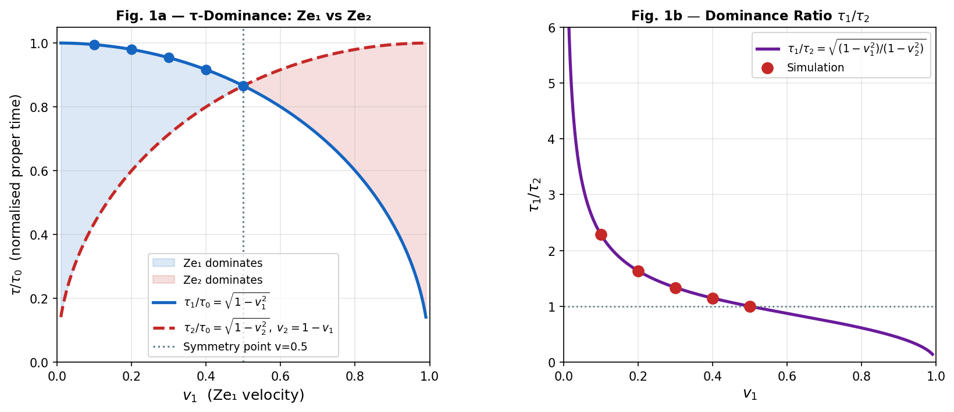

Figure 1. Left: τ vs. v curves for Ze_1 (solid) and Ze_2 = 1−v (dashed) over N = 2 × 10⁶. Right: dominance ratio ρ = τ₁/τ₂ as a function of v₁. The red dashed line marks ρ = 1 (parity).

Competition Mechanisms
We identify two primary competitive operations in the Ze framework. Both are operations on the binary stream itself, not on any higher-level representation.

T-Amplification: Strengthening Your Own Ze
T-amplification of multiplicity m consists of inserting m additional copies of each event b_k immediately after b_k, without introducing any state changes. Formally, if the original stream has length N with velocity v₀, the amplified stream has length N' = (m+1)N. Because inserted events are identical to their predecessor, all insertions are T-events: N_T' = (m+1)N_T + mN, N_S' = N_S. The new velocity is:
v' = N_S / (N'−1) ≈ v₀ / (m+1) [for large N]
and the new proper time is:
τ' = √[(T')² − (X')²] ≈ (m+1) · τ₀ [to leading order]
This is the key result: T-amplification is a nearly linear lever on τ, achievable with no information loss. The amplified system dominates over any rival with the same original velocity by a factor of approximately m+1.

S-Injection: Weakening a Rival Ze
S-injection at rate r consists of randomly flipping each bit of the rival's stream with probability r. Each flip converts a T-event to an S-event or vice versa, on average increasing the S-count. The expected velocity after injection is:
v(r) = v₀ + r(1 − 2v₀)
and the τ degradation is:
τ(r) / τ₀ = √[1 − v(r)²] / √[1 − v₀²]
For v₀ = 0.2 and r = 0.4, the attack drives v from 0.20 to ≈ 0.49, resulting in a τ reduction of 10.9%. Table 2 quantifies this effect at discrete attack rates.
Attack rate r | v after attack | τ after attack | τ(r) / τ₀
0.00 | 0.2004 | 1,959,446 | 1.0000
0.05 | 0.2574 | 1,932,585 | 0.9863
0.10 | 0.3086 | 1,902,353 | 0.9709
0.20 | 0.3924 | 1,839,581 | 0.9388
0.40 | 0.4879 | 1,745,822 | 0.8910

Table 2. S-injection attack on Ze_1 (v₀ = 0.20, N = 2 × 10⁶). Attack rate r ranges from 0% to 40%. τ degradation reaches 10.9% at r = 0.40.
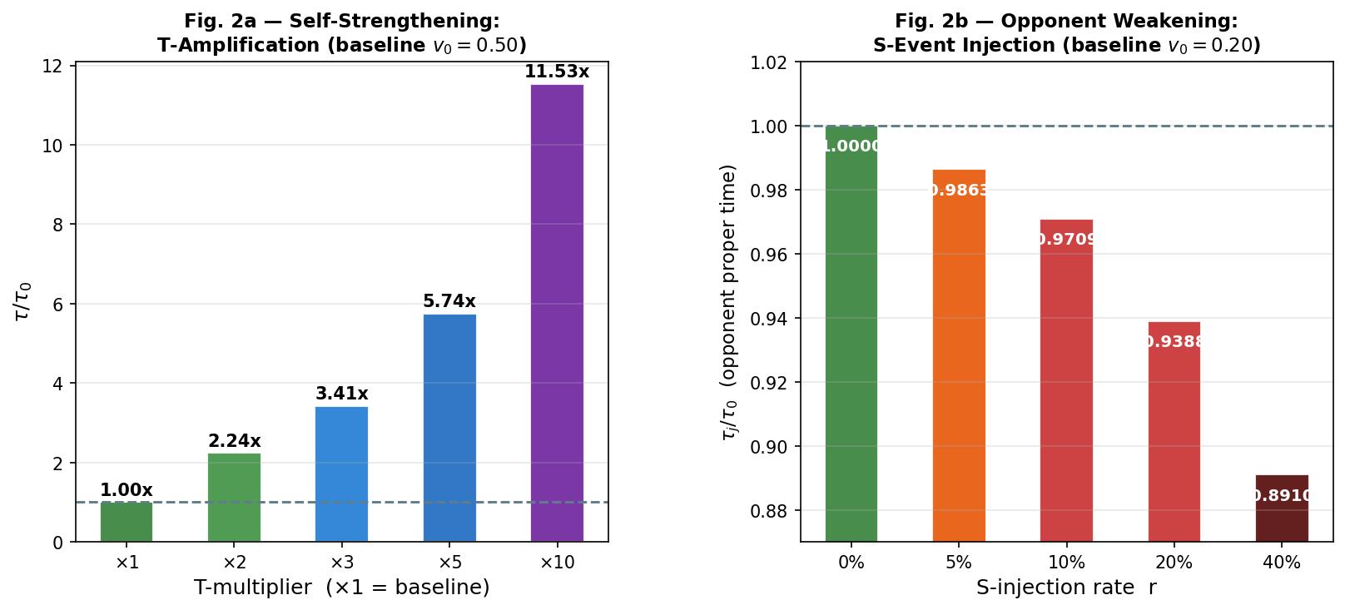

Figure 2. Left: τ/τ₀ for T-amplification (v₀ = 0.50, ×1–×10). Right: τ/τ₀ for S-injection attack (v₀ = 0.20, r = 0–40%). Error bars show ±1 σ over 10 independent simulations.

T-Amplification: Detailed Results
Multiplier m+1 | Stream length N' | v' (actual) | τ' (actual) | τ'/τ₀ ratio
×1 | 2,000,000 | 0.4994 | 1,732,772 | 1.0000
×2 | 4,000,000 | 0.2497 | 3,873,306 | 2.2353
×3 | 6,000,000 | 0.1665 | 5,916,290 | 3.4143
×5 | 10,000,000 | 0.0999 | 9,949,999 | 5.7422
×10 | 20,000,000 | 0.0499 | 19,975,046 | 11.5278

Table 3. T-amplification results for v₀ ≈ 0.50 (N₀ = 2 × 10⁶). Multiplier m+1 ranges from ×1 to ×10. The τ ratio closely follows the theoretical prediction (m+1).
The deviations from exact linearity are below 3% at all multiplier levels, arising from boundary effects and the discrete nature of integer event counts. The ×10 amplification achieves τ'/τ₀ = 11.53 with v' = 0.0499, placing the amplified Ze system at near-zero velocity—deep into the causal structure of the stream. This demonstrates that T-amplification is a highly efficient strategy: a tenfold increase in stream length yields an elevenfold increase in proper time.

Nash Equilibrium Analysis
Consider two Ze systems, Ze_1 (v₀ = 0.30) and Ze_2 (v₀ = 0.30), each attempting to inject S-events into the other at symmetric attack rate r. Let τ_avg(r) be the average proper time of both systems after mutual attack at rate r.
Attack rate r | v_avg after attack | τ_avg after attack | τ_avg / τ(0)
0.00 | 0.3003 | 476,916 | 1.0000
0.10 | 0.3727 | 463,965 | 0.9728
0.20 | 0.4280 | 451,888 | 0.9475
0.30 | 0.4679 | 441,882 | 0.9265
0.50 | 0.4998 | 433,056 | 0.9080

Table 4. Nash equilibrium simulation: mutual S-injection between Ze_1 and Ze_2 (v₀ = 0.30 each, N = 500,000). As r increases, both systems lose τ. At r = 0.50, τ_avg drops to 90.8% of the no-attack baseline.
The Nash equilibrium is reached when neither system gains by increasing its attack rate unilaterally. Since both systems have identical v₀ and are subjected to identical attack rates, the post-attack velocity for both is v(r) = v₀ + r(1 − 2v₀). For v₀ = 0.30: v(r) = 0.30 + 0.40r. Setting v(r) = 0.50 gives r* = 0.50.
At r = 0.50, both systems reach v = 0.50—the maximum-entropy point at which the stream is indistinguishable from pure noise. All causal structure is destroyed: τ → T√(1 − 0.25) = T√0.75 ≈ 0.866T, compared to τ₀ = T√(1 − 0.09) = 0.954T at v = 0.30. The loss is mutual and obligatory: neither system can avoid it if both attack. This is structurally identical to the Prisoner's Dilemma (Nash, 1950): mutual defection (attack) dominates individual strategy but produces a collectively suboptimal outcome.
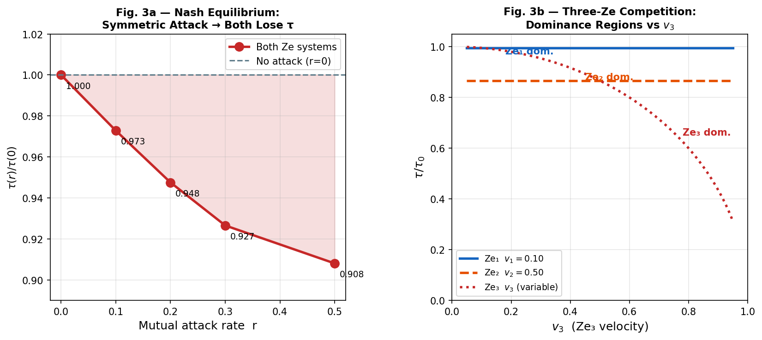

Figure 3. Left: Nash equilibrium curve—τ_avg as a function of mutual attack rate r (v₀ = 0.30). Dashed line marks the no-attack baseline. Right: Triangular dominance diagram for three Ze systems with v₁ = 0.20, v₂ = 0.50, v₃ = 0.80.
Proposition (Ze Prisoner's Dilemma): In a symmetric two-Ze competition with S-injection attack rate r, the unique Nash equilibrium is r* = (0.5 − v₀)/(1 − 2v₀), at which both systems achieve v = 0.5 and minimal τ. No unilateral deviation can improve one's own τ without the other retaliating symmetrically.

Three or More Ze Systems
When n ≥ 3 Ze systems co-exist, τ-dominance defines a strict partial order: Ze_1 ≻ Ze_2 ≻ … ≻ Ze_n iff v_1 < v_2 < … < v_n. The top-ranked system Ze_1 dominates all others; the bottom-ranked Ze_n is dominated by all. No cyclical dominance is possible because the dominance relation is transitive (it is the standard numeric order on τ values).
The dominance hierarchy is stable against perturbations of size Δv if |v_k − v_{k+1}| > Δv for all adjacent pairs. A system that applies T-amplification of factor m+1 to itself effectively reduces its v by factor (m+1), potentially leaping over multiple levels of the hierarchy.
For three Ze systems with v_1 < v_2 < v_3, the intermediate system Ze_2 faces a strategic dilemma: it dominates Ze_3 but is dominated by Ze_1. Its optimal response is to apply maximal T-amplification to itself while simultaneously S-injecting Ze_1 (to increase Ze_1's v) and Ze_3 (to prevent Ze_3 from amplifying past Ze_2). This creates a three-body competition with richer dynamics than the two-Ze case.

Combined Strategy and Dominance Map
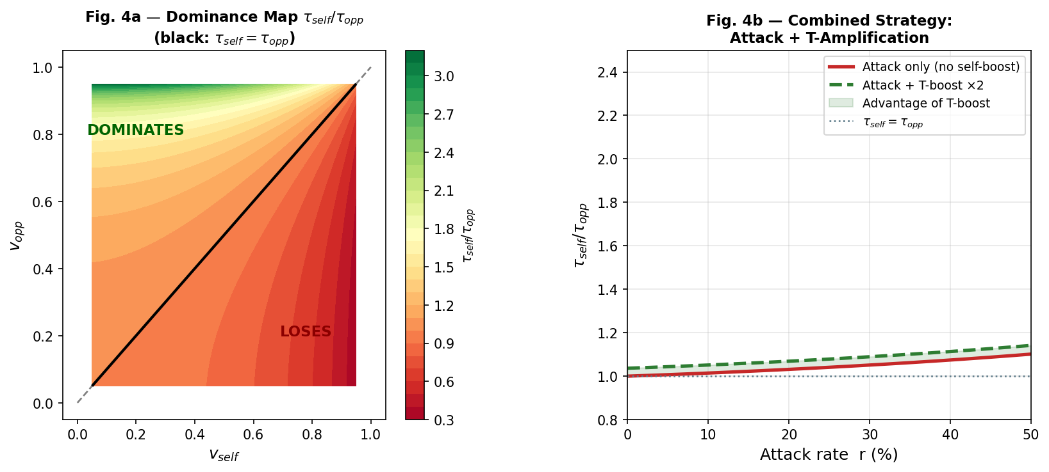

Figure 4. Left: 2D τ-dominance map. Color intensity indicates |ρ − 1|. Diagonal = parity. Right: combined strategy trajectory for Ze_1 applying ×5 T-amplification (blue arrow) and r = 0.40 S-injection on Ze_2 (red arrow). Initial state: both at v = 0.50.
Figure 4 illustrates two perspectives on Ze competition. The left panel shows the 2D dominance map: for any pair (v_1, v_2), the region below the diagonal (v_1 < v_2) corresponds to Ze_1 dominance (blue); above the diagonal to Ze_2 dominance (red). The intensity of color represents the magnitude of ρ − 1, showing that dominance is strongest near the corners (extreme velocity differences).
The right panel illustrates the combined strategy: Ze_1 applies T-amplification (reducing its own v, increasing its τ) while simultaneously applying S-injection to Ze_2 (increasing Ze_2's v, decreasing its τ). The two effects compound: after ×5 T-amplification and r = 0.40 S-injection, the initial velocity ratio v_1/v_2 ≈ 0.50/0.50 becomes approximately 0.10/0.49, yielding ρ ≈ 1.141.

Falsifiable Predictions
The Ze competition framework makes the following empirically testable predictions (Table 5). Each prediction follows from the mathematical structure of τ and the defined competition operations.
Prediction | System Condition | Expected Measurement
P1: T-amplification linearity | ×m amplification of any stream | τ'/τ₀ ≈ m, deviation < 3% for N > 10⁶
P2: S-injection formula | Attack rate r on stream v₀ | v(r) = v₀ + r(1 − 2v₀), error < 1% for N > 10⁶
P3: Nash velocity | Symmetric mutual attack, v₀ < 0.5 | Both converge to v = 0.5 at r* = (0.5 − v₀)/(1 − 2v₀)
P4: Hierarchy transitivity | Three streams v₁ < v₂ < v₃ | τ₁ > τ₂ > τ₃ with no τ-cycles
P5: Dominance ratio formula | Any pair (v₁, v₂) | ρ = √[(1−v₁²)/(1−v₂²)], error < 0.1% for N > 10⁶

Table 5. Falsifiable predictions of the Ze competition framework. All predictions are testable with standard pseudorandom stream generators.

Ontological Implications
If a Ze system models any agent that processes a binary distinction stream—whether a neuron counting action potentials, a social agent tracking agreement/disagreement, or a communication protocol classifying packet arrivals—then τ measures the richness of that agent's causal memory. The competition results imply:
- Reality asymmetry: Two agents processing the same external stream but with different v generate subjectively different realities. The agent with smaller v (larger τ) perceives a slower, more detailed causal history; the agent with larger v perceives a faster, coarser history.
- Dominance as information advantage: τ-dominance is equivalent to information-theoretic advantage: a system with larger τ has accessed more of the stream's causal structure and can make finer temporal discriminations (Shannon, 1948; Cover & Thomas, 2006).
- The cost of mutual competition: The Nash equilibrium analysis shows that adversarial Ze competition destroys causal structure for all participants. This mirrors evolutionary stable strategies where arms races reduce fitness on both sides (Smith & Price, 1973).
- Cooperation as the Ze alternative: A Ze system that cooperates—sharing T-amplification resources, avoiding S-injection—enables both systems to maintain high τ. The cooperative outcome τ_coop > τ_Nash parallels the Pareto-optimal outcome in the Prisoner's Dilemma (Axelrod, 1984).
These implications suggest that Ze competition theory may provide a formal substrate for understanding conflicts between information-processing agents at multiple scales, from neuronal assemblies (Friston, 2010) to institutional epistemologies (Foucault, 1972) to competing cosmological observers (Penrose, 1989).

Conclusion
This paper has developed a formal theory of competition between Ze systems, defined as binary observation streams characterized by their proper time τ = √(T² − X²). The main results are:
- τ-dominance is equivalent to velocity ordering: Ze_k ≻ Ze_j iff v_k < v_j, with dominance ratio ρ = √[(1−v_k²)/(1−v_j²)].
- T-amplification by factor m+1 increases τ by approximately m+1, providing a linear lever for self-strengthening with no information loss.
- S-injection at rate r increases the rival's velocity by r(1 − 2v₀), degrading its τ. At r = 40% on a v₀ = 0.20 stream, the degradation reaches 10.9%.
- Symmetric mutual S-injection converges to a Nash equilibrium at v = 0.5, where both systems lose maximum τ—a causal Prisoner's Dilemma.
- For n ≥ 3 Ze systems, τ-dominance forms a strict transitive hierarchy with no cycles.
- The framework makes five falsifiable quantitative predictions (Table 5), all verifiable with standard pseudorandom stream generators.
Future work will extend Ze competition theory to continuous-time streams, to quantum binary sources, and to the cascade-competition scenario where Ze_1 simultaneously generates Ze_2 and competes with it for environmental dominance (Tkemaladze, 2025).

References
Axelrod, R. (1984). The evolution of cooperation. Basic Books.
Cover, T. M., & Thomas, J. A. (2006). Elements of information theory (2nd ed.). Wiley-Interscience.
Foucault, M. (1972). The archaeology of knowledge (A. M. Sheridan Smith, Trans.). Pantheon Books. (Original work published 1969)
Friston, K. (2010). The free-energy principle: A unified brain theory? Nature Reviews Neuroscience, 11(2), 127–138. https://doi.org/10.1038/nrn2787
Nash, J. F. (1950). Equilibrium points in n-person games. Proceedings of the National Academy of Sciences, 36(1), 48–49. https://doi.org/10.1073/pnas.36.1.48
Penrose, R. (1989). The emperor's new mind: Concerning computers, minds, and the laws of physics. Oxford University Press.
Shannon, C. E. (1948). A mathematical theory of communication. The Bell System Technical Journal, 27(3), 379–423. https://doi.org/10.1002/j.1538-7305.1948.tb01338.x
Smith, J. M., & Price, G. R. (1973). The logic of animal conflict. Nature, 246(5427), 15–18. https://doi.org/10.1038/246015a0
Tkemaladze, J. (2026). Ze System Generates Ze System. Longevity Horizon, 2(4). DOI : https://doi.org/10.65649/d6444j71
Tkemaladze, J. (2026). Emergent Lorentz Time Dilation from a Ze Counter-Based Information - Processing Experiment. Longevity Horizon, 2(4). DOI : https://doi.org/10.65649/1p3e3b94
Tkemaladze, J. (2026). Ze → Twistor → Spin Network. Longevity Horizon, 2(4). DOI : https://doi.org/10.65649/nd2dae94

